TASK 01
#include <iostream>
using namespace std;

void selectionSort(int arr[], int n) {
for (int i = 0; i < n - 1; i++) {
int minIdx = i;
for (int j = i + 1; j < n; j++) {
if (arr[j] < arr[minIdx])
minIdx = j;
}
if (minIdx != i)
swap(arr[i], arr[minIdx]);
}
}

int main() {
int n;
cout << "Enter number of crates: ";
cin >> n;
int* crates = new int[n];
cout << "Enter shipping times for each crate:\n";
for (int i = 0; i < n; ++i) {
cout << "Crate " << (i + 1) << ": ";
cin >> crates[i];
}

selectionSort(crates, n);

cout << "Crates sorted by shipping time:\n";
for (int i = 0; i < n; ++i) {
cout << crates[i] << " ";
}
cout << endl;

delete[] crates;
return 0;
}
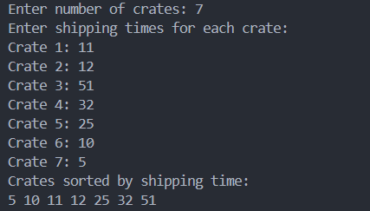

TASK 02
#include <iostream>
using namespace std;

void shellSort(int arr[], int n) {
for (int gap = n / 2; gap > 0; gap /= 2) {
for (int i = gap; i < n; i++) {
int temp = arr[i];
int j;
for (j = i; j >= gap && arr[j - gap] > temp; j -= gap) {
arr[j] = arr[j - gap];
}
arr[j] = temp;
}
}
}

int main() {
int n;
cout << "Enter number of bottles: ";
cin >> n;
int* arr = new int[n];
cout << "Enter fill levels: \n";
for (int i = 0; i < n; i++) {
cout << "Bottle " << (i + 1) << ": ";
cin >> arr[i];
}
shellSort(arr, n);
cout << "Sorted fill levels: ";
for (int i = 0; i < n; i++) {
cout << arr[i] << " ";
}
cout << endl;
delete[] arr;
return 0;
}
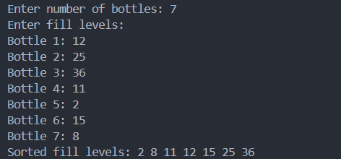
TASK 04
#include <iostream>
using namespace std;

void bubbleSort(int arr[], int n) {
for (int i = 0; i < n - 1; i++) {
for (int j = 0; j < n - 1; j++) {
if (arr[j] > arr[j + 1]) {
swap(arr[j], arr[j + 1]);
}
}
}
}

int main() {
int arr[] = {10, 2, 0, 14, 43, 25, 18, 1, 5, 45};
int n = sizeof(arr) / sizeof(arr[0]);
cout << "Original array: ";
for (int i = 0; i < n; i++) {
cout << arr[i] << " ";
}
bubbleSort(arr, n);
cout << "\nSorted array: ";
for (int i = 0; i < n; i++) {
cout << arr[i] << " ";
}

}

